Actions
Create the artefacts pre and post migration and save the file <ServerName_Artefacts.doc>
Pre-Migration Steps
- Make sure nightly full backup is completed successfully.
select serverproperty ('servername'),a.name, case b.type
when 'D' then 'Full Database Backup'
when 'I' THEN 'Differential Backup'
WHEN 'L' THEN 'Log Backup'
END AS Backup_Type,
max(b.backup_finish_date) LastSuccessfulBackup,
cast((getdate() - max(b.backup_finish_date)) as numeric(8, 2)) IntervalInDays
from master..sysdatabases a
LEFT OUTER JOIN msdb..backupset b ON a.name = b.database_name
type = 'D'
group by a.name, b.type
order by a.name, b.type
- Capture the System Information
Go the Run > msinfo32
- Capture running Services in the server including running and stopped services.
Run>Windows Powershell>C:\get-service
- Capture the IP Details
Run>cmd>C:\ipconfig /all
- Capture network connections for the Transmission Control Protocol, routing tables, and a number of network interface and network protocol statistics.
Run>cmd>C:\netstat-ano
- Capture available Disk Details
- Capture Windows Application and System from Event Viewer
- Connect the SQL Server Instance and capture the Database Status (Online/offline)
use master
go
select serverproperty ('servername') as [Instance Name],
name as [Database Name],state_desc as [Status] ,user_access_desc as [User Access Desc],
case is_auto_close_on
when 1 then 'ON'
when 0 then 'OFF'
end as [Auto Close]
from sys.databases
- Capture Always on Availability Status (Primary and Secondary) if applicable
- Capture SQL Server Error Log
- Capture Last Jobs Status
- Capture SQL Server Configuration Manager (SQL Server Services Status)
- Capture Backup Status (Full and Tran)
- Execute the query to check the Active Connection
SELECT
DB_NAME(dbid) as DBName, hostname,
COUNT(dbid) as NumberOfConnections,
loginame as LoginName
FROM
master..sysprocesses
WHERE
dbid > 0
GROUP BY
dbid, loginame,hostname
go
- Capture CPU, Memory and Disk Utilization
- Make sure SQL Server Instance or listener connected with or without SQL Port number from Tools Server and MSSQL Central Server.
- Stop the SQL Server Services (Change to manual)
Post Migration Steps
- Start the SQL Server Services (Change to Automatic)
- Perform Health Check of Database Server
- Check the connectivity of the Database Server from Tools and MSSQL Central
- Make sure both Cluster Nodes (if applicable) is accessible from
<WITNESS SERVER>\<CLUSTER SERVER>_QUORUM
- Failover and Fail back test between the Cluster Nodes
- Change the Recovery Model of <DBA_Maintenance> to Full Recovery Model
- Initiate the Full Backup and Transaction Log Backup of <DBA_Maintenance>
- Perform the restore test of <DBA_Maintenance> using DD Boost
- Disable the SQL Server Backup Jobs for Backup Strategy #1
- Disable the Backup Purging Jobs after 42 days
- Add <bcc\dev_ss_backup> or <bcc\uat_ss_backup> or <bcc\prd_ss_backup> account according to the environment as a Local Administrator on Database Servers
- Add and provide sysadmin privileges to <bcc\dev_ss_backup> or <bcc\uat_ss_backup> or <bcc\prd_ss_backup> account on Database Servers according to the environment.
- Following procedure is use to install, configure and schedule the Veeam Backup agent job on the SQL Database Servers.
- Make sure SQL Server’s running at following vApps, else raise this concern with respective Migration Team.

ENV | PROVIDER VDC | CLUSTER | ORG | ORG VDC | vApp | Location | Description
Prod | P-Polaris-SQL | SQL | SQL | or-SQL-Prod-P | P_vA_SQL-PRD | Polaris | Production  DR SQL Servers running in this vApp
Non-Prod | P-Polaris-SQL | SQL | SQL | or-SQL-Non-Prod-P | P_vA_SQL-UAT | Polaris | Non-Production  DR (UAT,DEV,TST) SQL Servers running in this vApp
Prod | P-Kenmore-SQL | SQL | SQL | or-SQL-Prod-K | K_vA_SQL-PRD | Kenmore | Production  DR SQL Servers running in this vApp
Non-Prod | P-Kenmore-SQL | SQL | SQL | or-SQL-Non-Prod-K | K_vA_SQL-UAT | Kenmore | Non-Production  DR (UAT, DEV, TST) SQL Servers running in this vApp
Prod | P-Polaris | COMPUTE | DCN | or-DCN-Prod-P | P_vA_SQLTools-PRD | Polaris | M915PRD1(Tools Server)
Non-Prod | P-Poralis | COMPUTE | Non-Prod | or-Non-Prod-P | P_vA_SQLTools-UAT | Polaris | M915UAT1(Tools Server)
Prod | P-Kenmore | COMPUTE | DCN | or-DCN-Prod-K | K_vA_SQLTools-PRD | Kenmore | M915PRD2(Tools Server)
Non-Prod | P-Kenmore | COMPUTE | Non-Prod | or-Non-Prod-K | K_vA_SQLTools-UAT | Kenmore | M915UAT2(Tools Server)
- Login to any one of the Tools Server (M915PRD1, M915PRD2, M915UAT1, M915UAT2)or M632PRD1 (Management Server for Windows Team)
- Go to the Internet explorer and disable the proxy
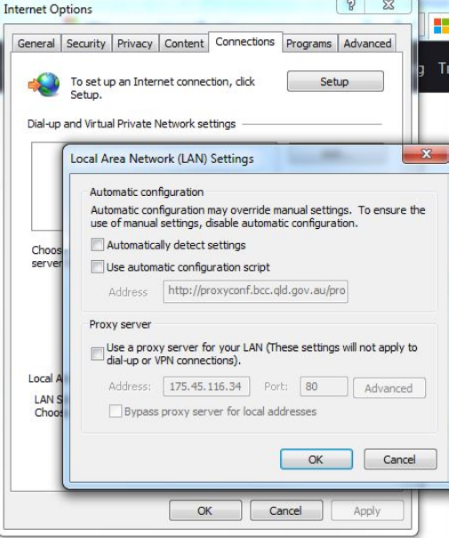
- Go to the Chrome and enter the url https://bccvcloud01.bcciaas.local and provide your credential to access the vCloud Director
- Once you logged in click on Manage organisations
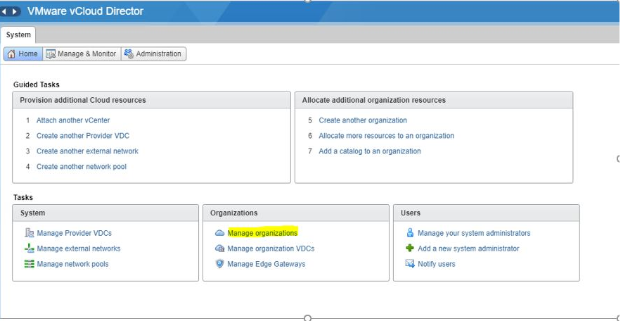
- Select the Organization <SQL> to check all the vApps running under this organization
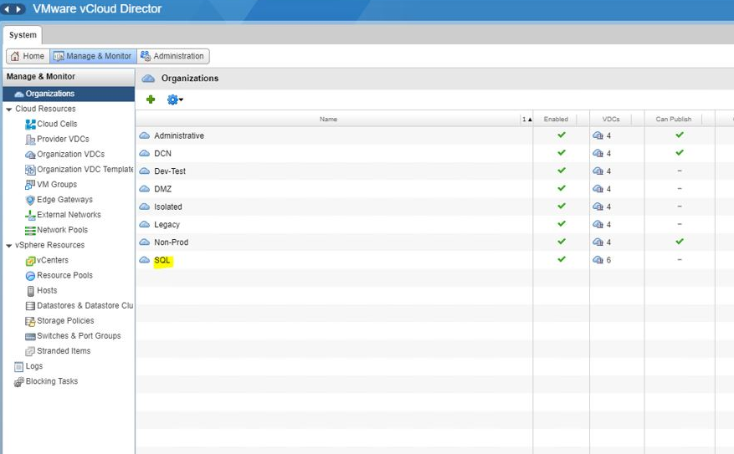
- Click the SQL vApps under SQL organization as per above standard naming convention (e.g. P_vA_SQL-PRD)
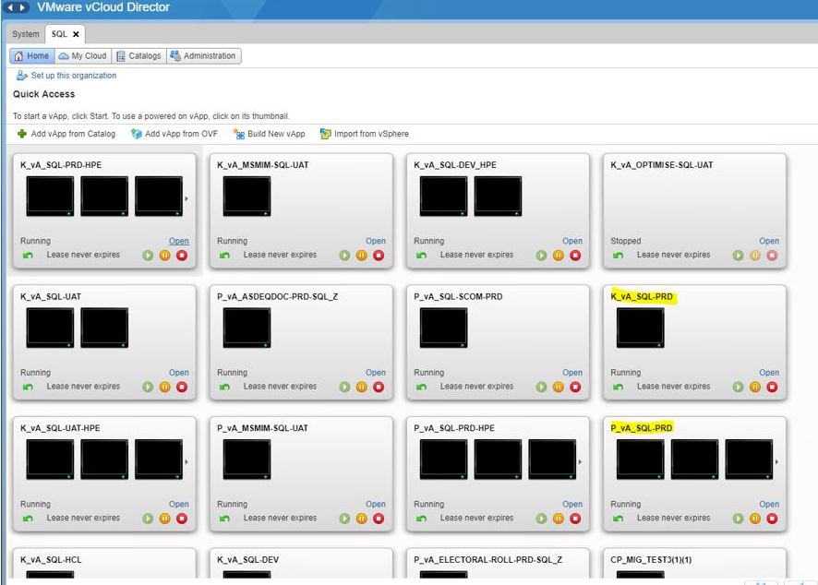
- Verify the migrated servers running under the particular vApp
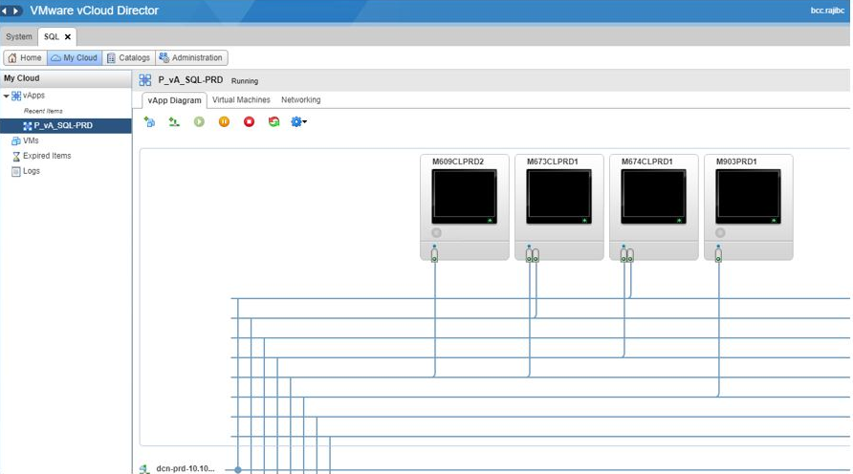
- Execute the following script on guest machine.
--Update on Migrated Guest Machine
--In case of HPD Update the value1 with 'BCC SQL Cluster Polaris'
--In case of BSQ Update the value1 with 'BCC SQL Cluster Kenmore'
use [DBA_Maintenance]
go
select * from DBA_Maintenance.bcc.global_constants where name ='CLUSTER NAME'
go
update DBA_Maintenance.bcc.global_constants
set value1 = '<CLUSTER_NAME>' --BCC SQL Cluster Polaris/BCC SQL Cluster Kenmore
where name = 'CLUSTER NAME'
go
- Initiate the <DBA_MaintenancePlan.Update SQL Server Central> Job on guest machine
- Execute the following script on MSSQL_Central (M903PRD1)
--MSSQL_Central (M903PRD1)
--In case of HPD Update the Datacenter with ‘POLARIS'
--In case of BSQ Update the Datacenter with 'KENMORE'
use [Database_Central]
go
select * from bcc.mssqL_datacenter_details where Computer_Name = '<Computer_Name>'
Go
update bcc.mssql_datacenter_details
set Datacenter = '<DC>' -- POLARIS/KENMORE
where Computer_Name = '<Computer_Name>' --New Migrated Server
go

